KC United! Youth Football & Cheer
2022 PHYSICAL FITNESS & MEDICAL HISTORY FORM

ASSOCIATION NAME____________________________________________

Note: This form must be dated after January 1, 2022 and then submitted to KC United! Youth Football & Cheer. Section II must be completed in its entirety ONLY by a Licensed State Examiner (medical doctor, nurse practitioner, etc. – this may vary by state) This form along with Medical Clearance Form are acceptable unless Section II is modified or substituted ONLY to comply with local and/or state laws or because of medical practitioner regulations (i.e. the medical practice insists on its own form). In either case, Section I must still be filled out entirely and attached to the modified/substituted form.
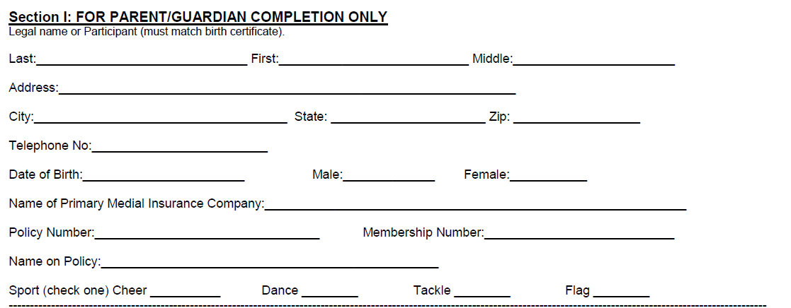

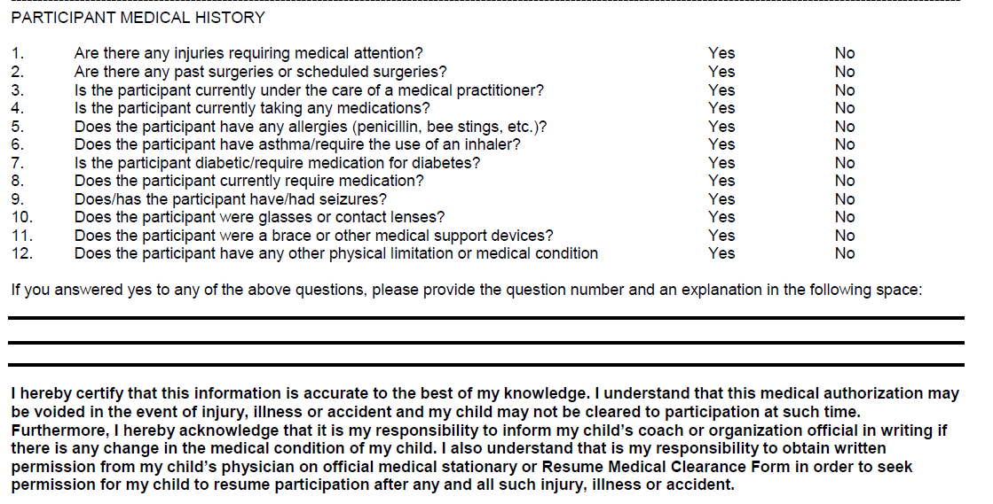
KC! United Youth Football & Cheer – 2022 SEASON

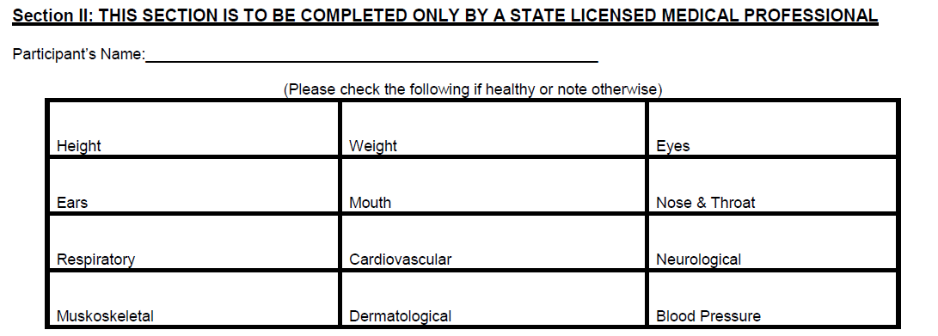

I hereby certify that I am licensed state examiner and have examined the above named individual and understand that he/she will be involved in participating in youth football, cheer or dance programs. I hereby swear and attest that this individual is physically fit and I have found no medical reason which would prevent this individual from safely participating in Central Midwest Conference activities for the 2022 season. I am therefore clearing this individual for athletic participation without limitation.

Please place medical professional stamp here or fill out the following:

Signed: _________________________________ Date: ______________________________

Print Name: ___________________________________

Please indicate medical profession (M.D., D.O., R.N., etc.): ________________________________

Address: _____________________________________________________________________

City: ___________________________ State: __________ Zip: _________________________

Telephone: _________________________________________

